Lecture No.32 PARASITOLOGY DR. Raad H.H.
Class Insecta ( Hexapoda )
General characters :
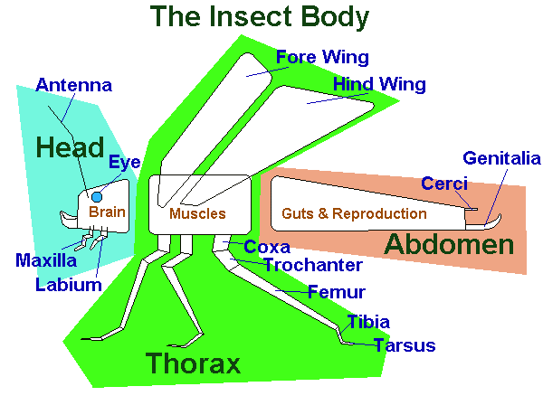

- The body of Insecta divided in to 3 parts :
- Head ; which have :
- Pair of compound eyes ; they are separated in females♀ & called "Dicoptic " ; and they are closely in the males ♂ & called "Holoptic".
- 1 or 2 pairs of simple eyes & called "Ocilli".
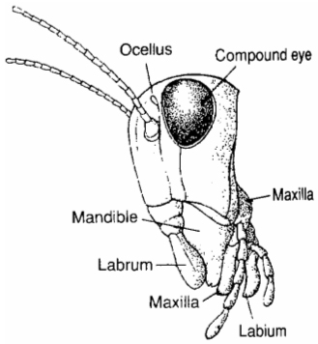
- One pair of segmented antenna .
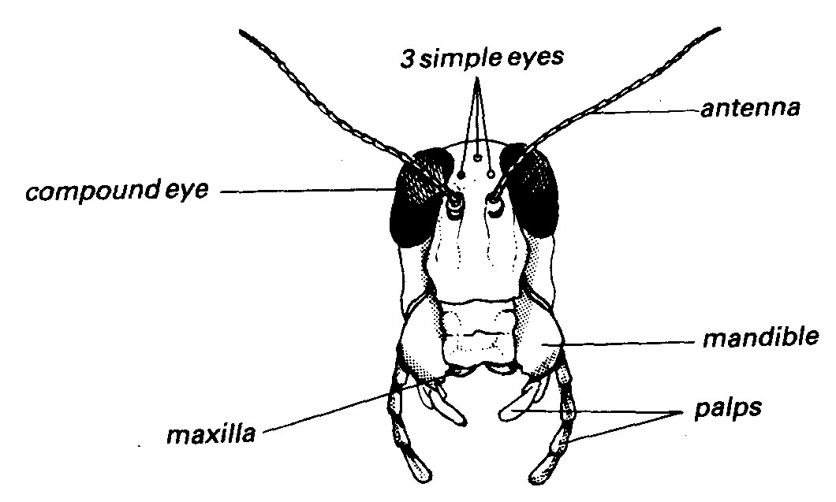
- Appendages modified to feeding .

- Thorax ; which have "3 jointed segments ":
- 1 or 2 pairs of wings located on the last 2 segments .
- One pair of walking legs on each segments .
- In the Insecta , the 2nd. Wing is reduced to a Balance Knob called the " Halters ".
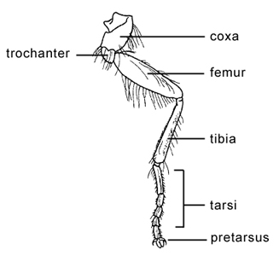

- Abdomen ; which have "jointed 8 – 10 segments" :the appendages on the last segments are modified for external genitalia in the ♂ & to the ovipositor in the ♀.
- Types of Insecta larvae :
- Poly pods → they have legs in the head & abdomen e.g. butter fly .
- Oligo pods → they have 3 pairs of legs in the thorax region e.g. Beetles .
- Apodos → they have no legs & also called " Maggot" as in Order Diptera e.g. Musca flies .

- Classification of class Insecta:

▼ ▼
1) Order Orthoptera (cockroaches) . 1) Order Coleoptera ( beetles)
2) = Phthiraptera
Sub = Mallophaga (chewing lice) . 2) = Siphoptera ( fleas)
sub = Anoplora ( sucking lice) . 3) = Hymenoptera (bees)
3) = Hemiptera ( bugs) . 4) = Diptera (flies;mosquitos)
▼ ▼
{ Ametabola metamorphosis} {Metabola metamorphosis}

- Subclass Pterygota
- Exopterygota
Order Orthoptera (cockroaches) .
Blattaria
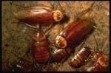

Common name: cockroaches
Mouthparts: chewing
Characteristics: Blattaria are cursorial (adapted for running) and move rapidly. They have flattened bodies and a head concealed from above by the pronotum. They have two pairs of wings, but in some species the wings are greatly reduced.
Biology: Cockroaches are somewhat general feeders, but prefer materials high in fats and starches. They deposit their eggs in a capsule called an ootheca. Several species invade homes where they can contaminate food. They have an unpleasant odor and can be very annoying.
Name derivation: Blattaria = Greek word meaning “shuns light”

Order Phthiraptera
Suborder Anoplora ( Sucking lice )

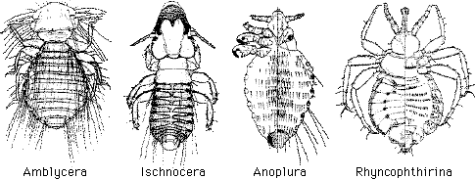

Characteristics
- sucking lice
- less than 500 described species infest mammals only
- ingest blood
- wingless
- dorso-ventrally flattened
- Compound eyes absent or present; if present no ocelli
- Antennae short, filiform, three or usually five segmented.
- separate sexes
- 0.35 – 8 mm long.
- eggs usually cemented to hair of the host
- Head usually conical, often pointed and usually narrower than prothorax
- mouthparts retracted into the head when not feeding
- Legs often well developed with a modified tibia and first legs with terminal claw
- Abdomen comprises eight pregenital segments, although the most anterior pair are usually fused.
- The ninth visible segment bears the genital apparatus.
- Thorax usually small and completely fused bearing a single pair of spiracles.
- Six, three, two or a single pair of spiracles borne on segments III-VIII.
- abdomen segments with Paratergal Plates (dark chitinous)
- typical life-cycle
  - eggs (nits) attached to hair; body louse of humans cements eggs to clothing fibers
  - a nymph hatches 3-14 days later
  - 3 nymphal instars (about 1 week each)
  - molt into adult; mate
- Three families
    - Haematopinidae
    - Linognathidae
    - Pediculidae
Family Haematopinidae
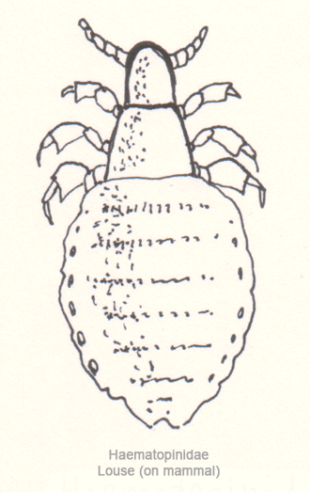

Characters
- Large lice 4-5 mm.
- They possessed prominent Angular Processes known as Ocular points or Temporal Angles ,behind the antenna .
- Eyes absent.
- Thoracic sterna plates dark well developed.
- Paratergal plates visible on abdominal segments 2 or 3 to 8.
- Each abdominal segments had one raw of spines .
- Legs are similar size terminating in a single large claw.
- One genus Haematopinus.

Haematopinus asini (equine)
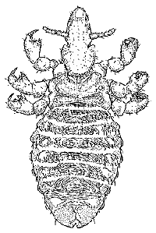

Haematopinus suis(pigs)
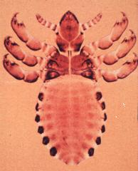

The hog louse is yellowish in color, less than 1/16 inch long, with chewing mouthparts. This chewing louse has a wide head necessary to hold the mandibles that are part of the mouthparts.
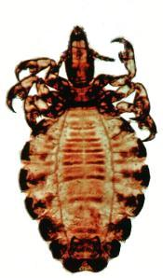
Haematopinus quadripertusus (cattle)

Short-nosed Cattle Louse
Scientific name: Haematopinus eurysternus
Facts: The short-nosed cattle louse lives on and sucks blood from cattle. These wingless insects are only 1/20 to 1/16 inch long. Whereas chewing lice have wide heads, sucking lice have narrow heads.

Family Linognathidae
- Eyes absent.
- 2nd. And 3rd. Legs are larger than 1st. terminating in a single large claw.
- Paratergal plates absent.
- Abdomen membranous
- Mostly ungulate lice.
- Species members :
Linognathus africanus sheep
Linognathus ovillus = (sheep face or blue louse),
Linognathus pedalis = hairless parts of limbs of sheep, called also foot louse
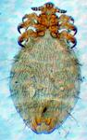

Linognathus vituli cattle (cattle—called also long-nosed cattle louse).

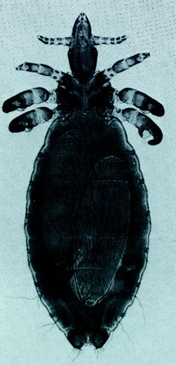

Linognathus stenopsis goat
L. setosus (fox, dog)
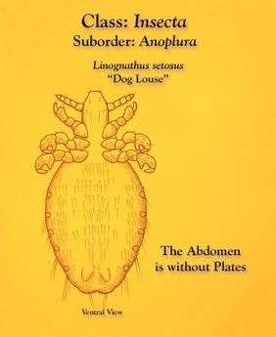

Solenopotes capillatus cattle

Family Pediculidae
- Pediculus humanus capitis ( Scalp head louse ).
- = = humanus ( body louse).
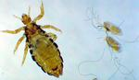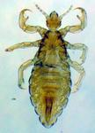
- Ptherus pubis ( pubic louse ).
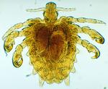

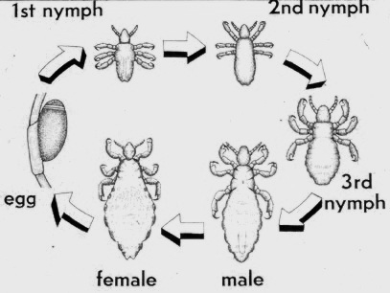

- body shape is flattened dorsoventrally ; No wings
- Lice are external ; Ectoparasites.
- Lice feeding on Human blood & fluids ; also transmits diseases agents e.g. typhus.
- Could be diagnosed popularly by using ultra violet light (wood's light) for screening school students etc. to see lice nits &eggs.
- Treatment :
  - Permethrin 1% crème rinse applied to affected areas and washed off after 10 minutes. OR
  - Lindane 1% shampoo applied for 4 minutes to the affected area, and then thoroughly washed off. This regimen is not recommended for pregnant or lactating women or for children aged less than 2 years. OR
  - Pyrethrins with piperonyl butoxide applied to the affected area and washed off after 10 minutes.

Sub Order: Mallophaga (chewing lice)

Chewing lice with their large head and mandibles comprise the largest group with some 2900 species. These are separable into three distinct superfamilies - the Amblycera, Ischnocera and Rhyncophthirina.
Amblycerans are found on a diverse range of mammals and birds, and have retained some of the more primitive characteristics of the order, with a lesser degree of specialization for particular habitats. This is reflected in their classification, and they divided into around sixty homogenous genera.
the Ischnocera are contained by over a hundred and fifty genera, of which around three quarters are confined to birds.
Amblycera chew away at younger feathers and soft areas of the skin, causing localized bleeding from which some can drink. They usually roam freely about the surface of their host and seldom attach firmly to fur or feathers, unlike the avian Ischnocera which are more site specific, and will attach securely to the feathers or fur to escape the preening activity of their host.
Ischnocera confine themselves to feeding on the downy part of feathers and softer fur.
The Rhyncophthirina comprises a single genus which parasitise elephants and wart-hogs. They are a small louse carrying mandibles at the end of a long proboscis-like snout. This allows them to drill through their hosts thick skin.
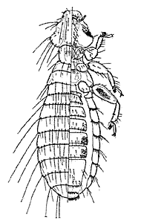 Amblycera
Sub Order: Mallophaga
Characters:
- chewing lice
- over 3,000 described species
- infest birds and mammals; most on birds
- most ingest feathers or hair; some live off epithelial cells, mucus, or even sebaceous secretions; a few chew into quills of birds and feed on blood
- wingless
- dorso-ventrally flattened
- no ocelli
- antennae short, with 3-5 segments
- separate sexes
- fusion of mesothorax and metathorax in one segment
- tarsi of birds lice with pairs of claws
- tarsi of mammals with single claw.
- eggs usually cemented to feathers or hair of the host
- head usually broader than prothorax
- mandibles conspicuous, used to cut off pieces of feathers or hair; maxillae and labium reduced
- species may cause dermal lesions, feather or hair damage, irritation, restlessness, etc.
- typical life-cycle
  - eggs attached to hair or feathers
  - a nymph hatches 3-14 days later
  - 3 nymphal instars (about 1 week each)
  - molt into adult; mate
- 3 Super families :
  - Super family Amblycera
    - maxillary palps present
    - antennae carried in ventro-lateral grooves on head
    - antennae with 4 (rarely 5) joints; the third being stalked; antennae may (slightly) or may not project from sides of head
    - horizontal chewing type.
    - tend to be generalists and many species non-host specific
    - about 6 families; Boopidae (ca 7 genera, on Australian marsupials and Casuariidae), Gyropidae (ca 9 genera, on Central and South American rodents and marsupials), Laemobothriidae (1 genus, on birds), Menoponidae (ca 72 genera, all on birds), Ricinidae (ca 3 genera, all on birds), and Trimenoponidae (ca 5 genera, on Central and South American rodents and marsupials)
    - some representative species
      - Gliricola porcelli (guinea pigs)
      - Gyropus ovalis (guinea pigs)
      - Menacanthus stramineus (yellow body louse of chickens and turkeys; prefers skin and can cause severe irritation)
      - Menopon gallinae (shaft louse of galliform and anseriform birds)
      - Heterodoxus spiniger (dogs)

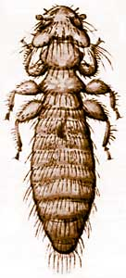
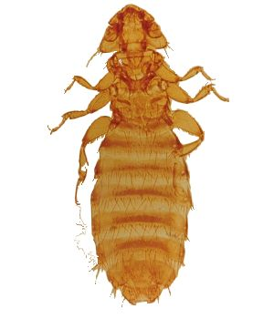
Menacanthus stramineus

Menopon gallinae
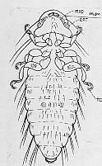
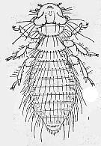

Gyropus ovalis
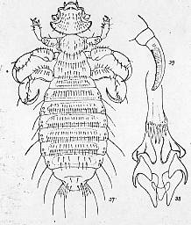

  - Super family Ischnocera
    - maxillary palps absent
    - antennae filiform and conspicuous, with 3 or 5 joints; stick out prominently from side of head
    - vertical chewing type
    - 1st. and 2nd. , 9th. and 10th. abdominal segments fused
    - food confined to feathers or hair; species in birds sometimes confined to specific sites on body
    - most species specific for specific hosts
    - two families, Trichodectidae (ca 20 genera, all on mammals) and Philopteridae (ca 134 genera, all on birds). Some authors break these 2 families up into 5 different families
    - some representative species
      - Anaticola anseris and Anaticola crassicornis (duck lice)
      - Damalinia(Bovicola) bovis (cattle louse; many other species of the genus on other animals)
      - Damalinia(Bovicola) ovis (ovine louse)
      - Damalinia(Bovicola) caprae (goat louse)
      - Damalinia(Bovicola) equi (equine louse)
      - Columbicola columbae (slender pigeon louse)
      - Cuclotogaster heterographus (chicken head louse)
      - Felicola subrostratus (cat louse)
      - Goniocotes bidentatus (pigeon louse)
      - Goniocotes gallinae (fluff louse of chickens)
      - Goniocoites gigas (giant chicken louse)
      - Goniodes dissimilis (reddish-brown chicken louse)
      - Lipeurus caponis (wing louse)
      - Oxylipeurus polytrapzius (slender turkey louse)
      - Strigiphilus garylarsoni (owl louse)
      - Trichodectes canis (dog louse)
      - Trichodectes tibalis (deer in western US)

Columbicola columbae
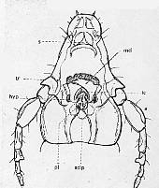
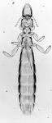

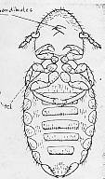
Bovicola bovis
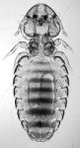

Trichodectes canis
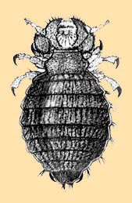

Trinoton querquedulae
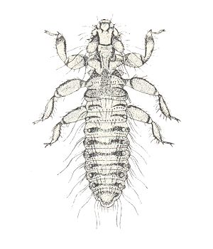

Lipeurus caponis
Lipeurus caponis
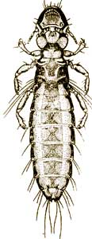

  - Super family Rhynchophthirina
    - maxillary palps absent
    - mouthparts at end of projecting structure
    - feed on blood
    - only 3 known species, all apparently of African origin and in the genus Haematomyzus

